|  |  |  |  |  |
| --- | --- | --- | --- | --- |
| Read a book in a series | Read Outside | Read with a flashlight | Read a book Mom chooses | Reread a book you enjoy |
| Write A Letter To Family | Read A Fairy Tale | Read a Joke Book | Make A Craft From A Book | Read in you pajamas |
| Read in a blanket fort | Read for 15 Minutes | Free Space | Read a story about an animal | Read Outside |
| Read a story by Kevin Henkes | Draw a character from a Book | Read Under A Tree | Read at lunch | Let your adult choose a book! |
| Help write a grocery list | Listen to a story on YouTube | Read a bedtime story | Read for 15 minutes | Read a book about Vehicles |

**This Week’s Upcoming Events:**

Monday July 20th @ 3pm – Choose Your Own Adventure Read-A-Long via Zoom (Zoom link on Facebook & Instagram)

Tuesday July 21st @ 11am– Craft Time – Hovercrafts!

Wednesday July 22nd @ 1pm – Exploding Chalk Paint

Thursday July 23rd @ 10:30am – Baby Play Date – Egg Shakers

Friday July 24th @ 10:30am– Storytime – The Three Bears stories

* **Choose ONE prize from the back of this sheet and return to the library**



DIY Paint Your Own Squishies



Monster Jam Champ Ramp





Wireless Bluetooth Microphone

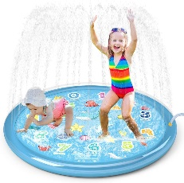 BONUS! $5 Texas Hot Gift Certificate!

60” Splash Pad

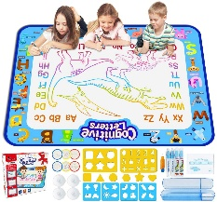

Aqua Doodle Mat

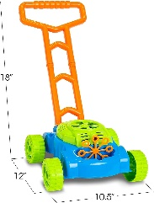 BONUS! $5 Texas Hot Gift Certificate!

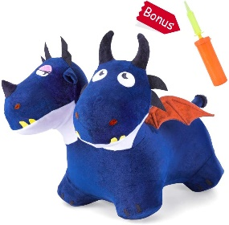 Bubble Lawn Mower

BONUS! $5 Texas Hot Gift Certificate

Two Headed Hopping Dragon

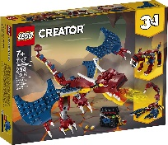

234 Piece Dragon LEGO Building Kit

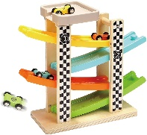

Wooden Race Track Car Ramp



Hot Wheels 20 Car Variety Pack

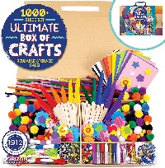

1000+ Piece Craft Box

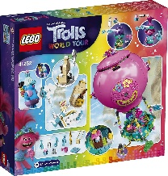



LEGO Trolls World Tour 250 Piece Kit

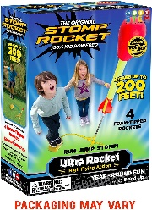

Stomp Rocket

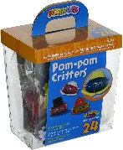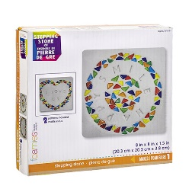

Stepping Stone Craft Kit

Pom Pom Critter Craft

BONUS! $5 Texas Hot Gift Certificate

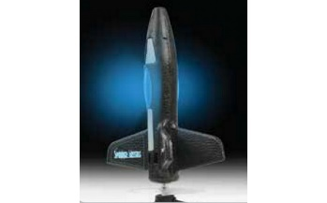

Spinner Missile

Thank you to all the generous donors who added to our Summer Reading Program Prizes this year:

**Generous Friend of the Library**

**Texas Hot of Wellsville**

**Inspire Crafts and Hobbies**